Use Case 2:

1) Create a custom field called “Risk” with values as High, Low, Medium.

2) When the value “High” is selected, trigger a platform event.

3) Platform event should be subscribed, and case should be created. Case Owner should be a user different than account own

Soln :

Create Custom Field "Risk"

* + Type : Picklist
  + Field Label: Risk.
  + Values: High, Medium, and Low

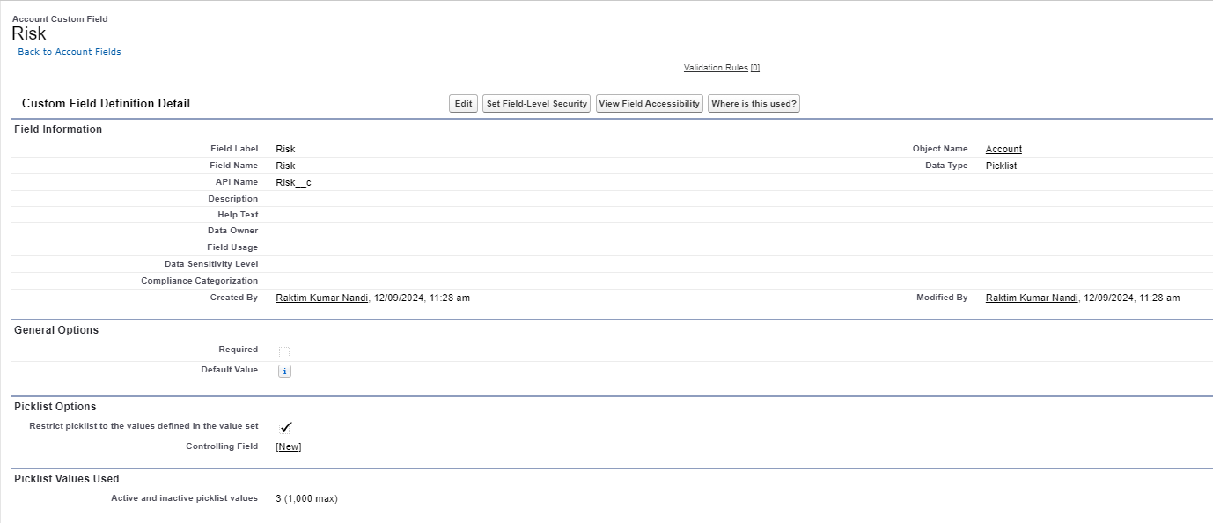

>> Create the Platform Event:

* Name: Risk Event.
* Select Publish Immediately.
* Create fields in the platform event, such as:
  + AccountId(Text)
  + Risk(Text)

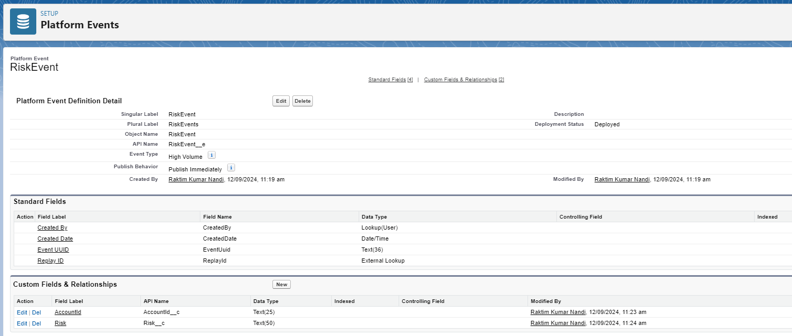

### Create Apex Trigger to Fire Platform Event

Create an Apex trigger those fires when the Risk field is updated to "High". This trigger will publish the platform event.

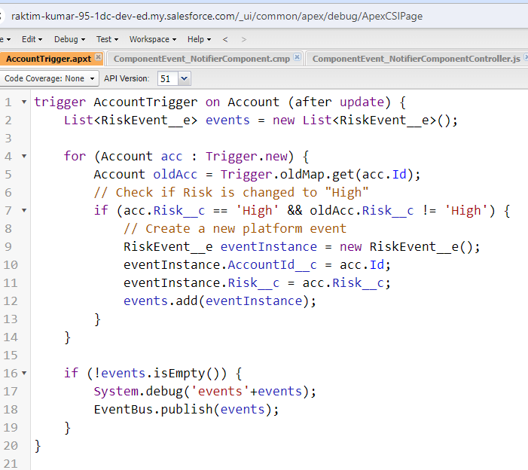

Testing :

Publish the event satisfying Trigger Condition.  
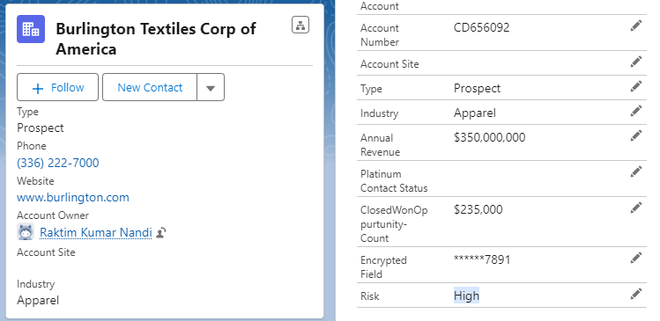

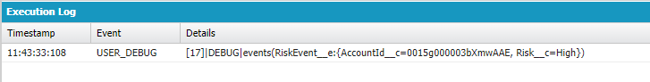

Subscribing the Event in External System from Salesforce:

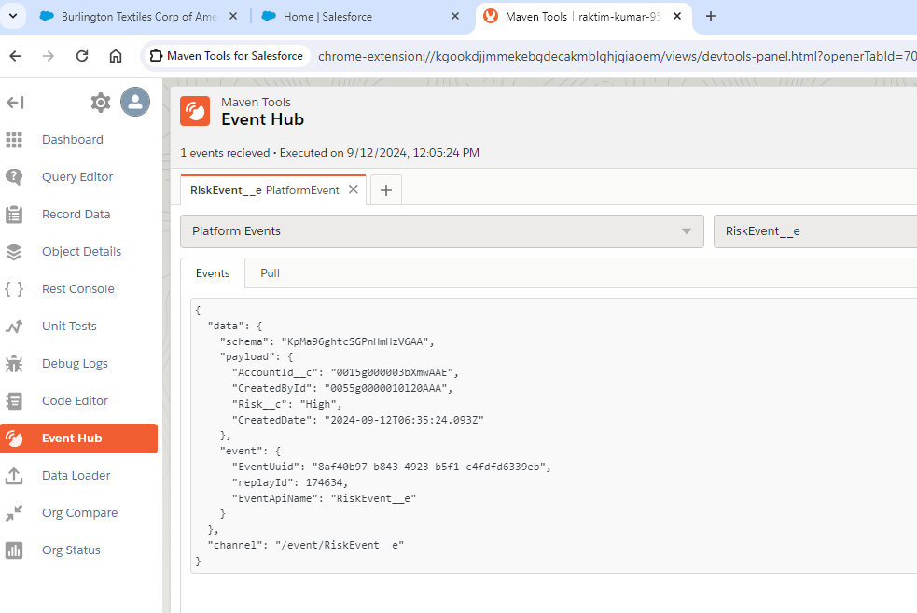

>>> Subscribe the Event in Salesforce :  
Create another trigger that listens to the platform event, creates a case, and assigns it to a user different than the account owner  
  
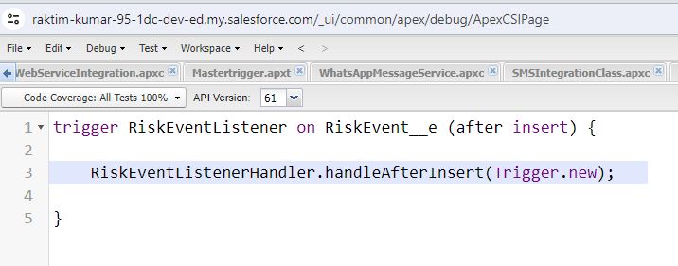

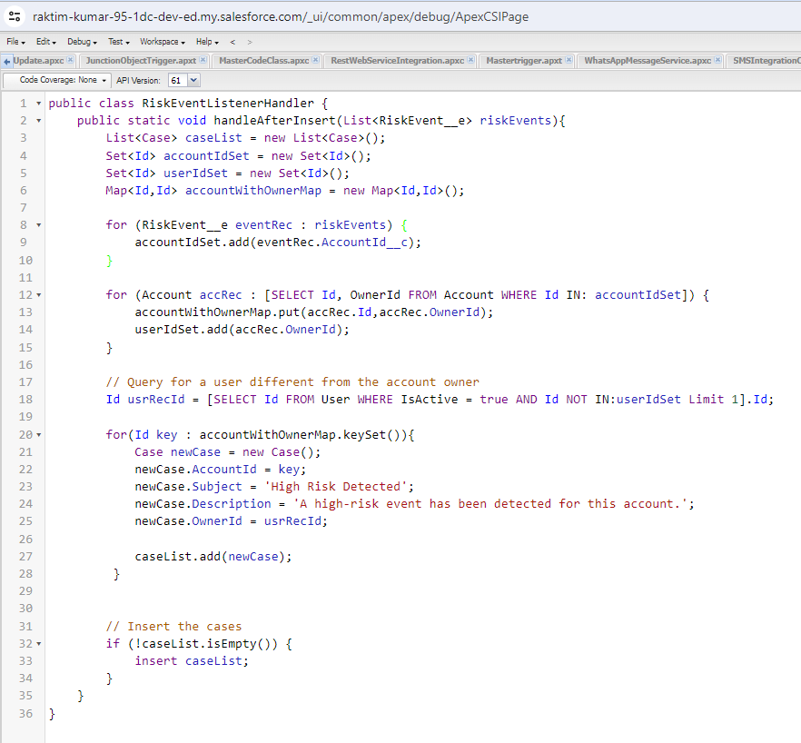

Testing :   
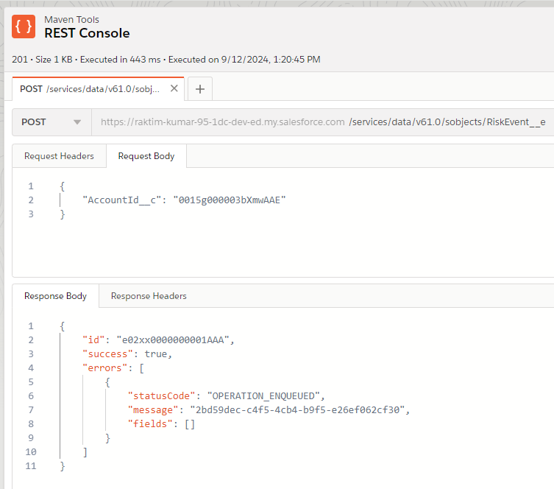

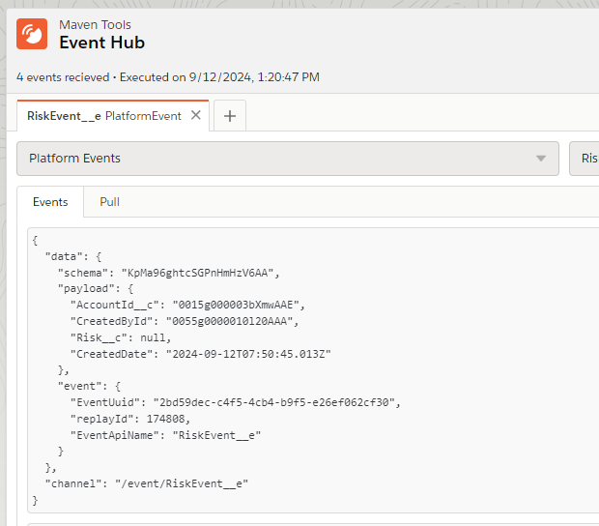

Test Class to test the Publish and Subscribe Event :

